**Fall 2021 JEE 2340 Laboratory 9**

**Transistor Application: Building a RollerBot**

Lab to be done individually this week (November 29). You are allowed to discuss with fellow students if you are stuck. Take your time and follow the procedure carefully for successful assembly. Lab is to be completed by 7:30pm for JEE2340.01 and by 10pm for JEE2340.02.

**Please note that given the large size of the two sections combined, attendance is mandatory to complete the Lab on 11/29. It will be very difficult to make up the Lab for multiple students. Make up sessions will be allowed only for valid excuses per the syllabus. For instance, having an exam in another class will not be a valid excuse. If you are in doubt, please email me in advance (at least 24 hours prior to November 29— 3:00pm) and we can determine if your excuse is valid. I may ask we discuss over zoom. Failure to complete the Lab on November 29 without a valid excuse will result in a grade of zero (0) for Lab 09.**

**100 %** if you can demonstrate a moving robot without help from instructor or TA.

**95%** if you get your robot to move with instructor/TA help.

**90%** if circuit is correct but rollerbot is not moving.

**Other grade (<90%)** will be assigned for incorrect circuit…

Bonus points: +2 points if your robot moves 1 foot.

**9.1 Supplies**

* Solder-less Breadboard
* MPSA13 Transistor
* 68 kΩ Resistor
* 1⁄4” rubber band
* Zip ties
* Electrical tape
* 3” paint roller
* DC motor
* 9V battery
* Photodiode

**The instructor will have a few portable DMMs set up on the main table. Make sure you measure resistance and battery voltage before you start assembling your circuit.**

**9.2 Robot Assembly**

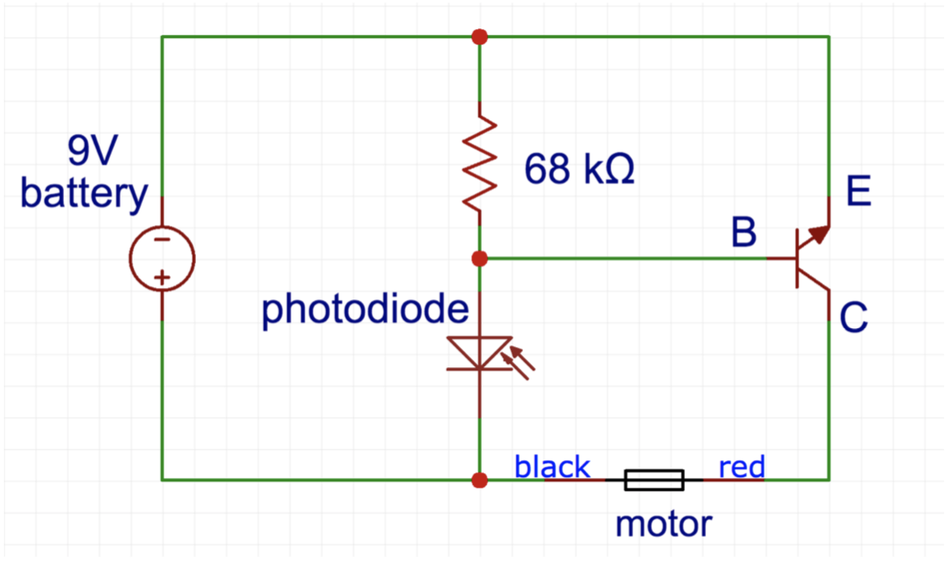

**Figure 9.1**: RollerBot circuit.

**Figure 9.1** shows the RollerBot circuit. Connect the circuit using the steps below. **Make certain that the battery is always disconnected while making the electrical connections**. Failure to do so will cause permanent damage to the transistor.

**Step 1:** Use a zip tie to tightly secure the DC motor to the top edge of the breadboard as shown in Figure 9.2. Your breadboard may look different, but you know the working principle of breadboards.

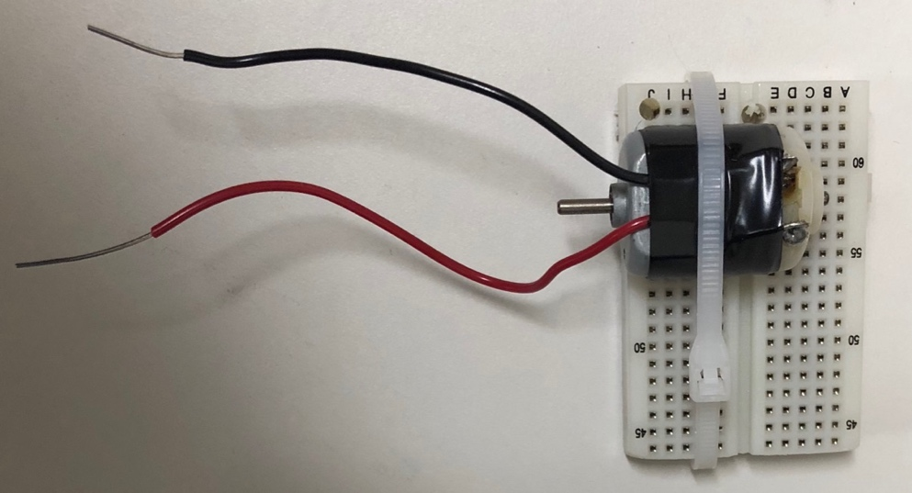

**Figure 9.2** Secure the DC motor

**Step 2:** Figure 9.3 shows the leads of the transistor you will be using for the RollerBot assembly. Use the pictures to identify the Emitter, Base, and Collector connections on the transistor. In the picture, the flat side of the transistor is on top.

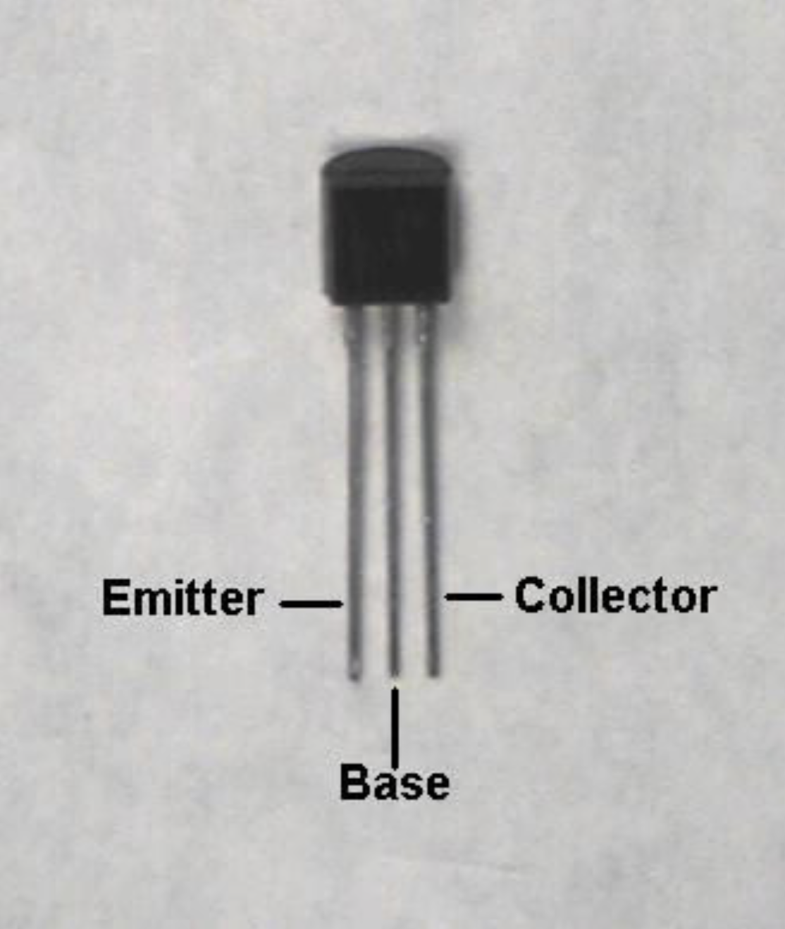

**Figure 9.3** Transistor leads

**Step 3:** Insert the leads on the breadboard so that each lead is in its own row, as shown in figure 9.4. If you place all three leads in the same row, you will short the transistor and possibly damage it.

emitter base (middle)

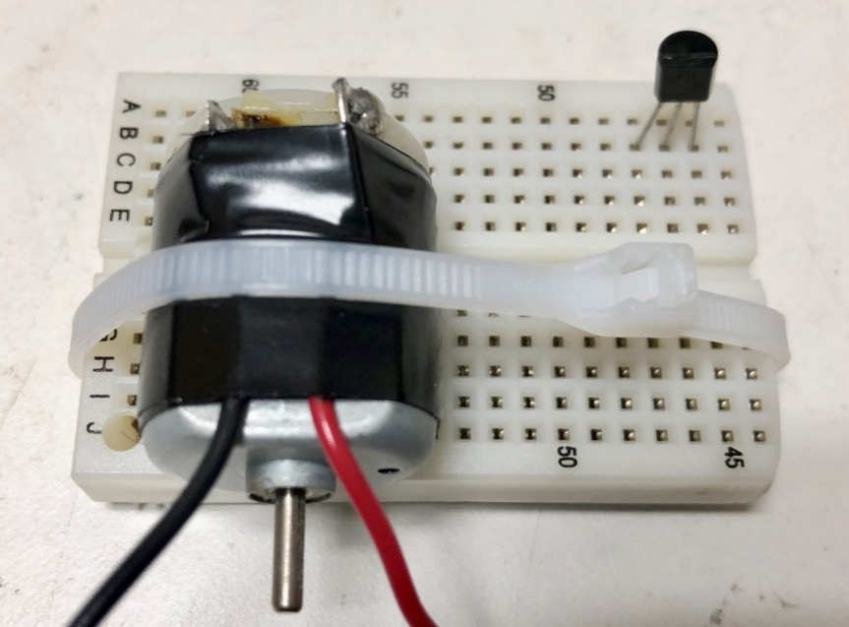 collector

**Figure 9.4** Transistor on breadboard

**Step 4:** Use Figure 9.5 and 9.6 to connect the photodiode on the breadboard such that the anode is connected to the base (middle lead) of the transistor. On the photodiodes we are using, identify the anode with a metal strip and dot on the anode side. Make sure you do not block the photodiode with wires, zip-ties, etc. You will shine light on this diode to start the motor.

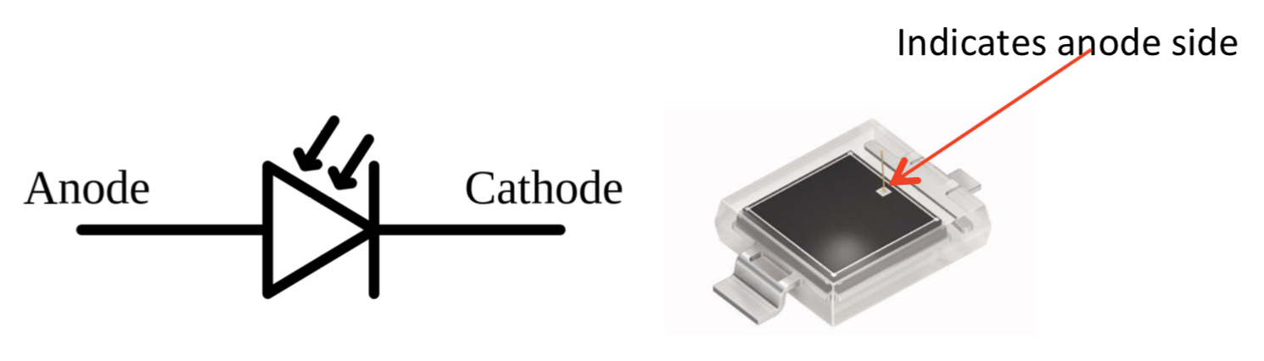

**Figure 9.5** Photodiode leads

Transistor base photodiode anode

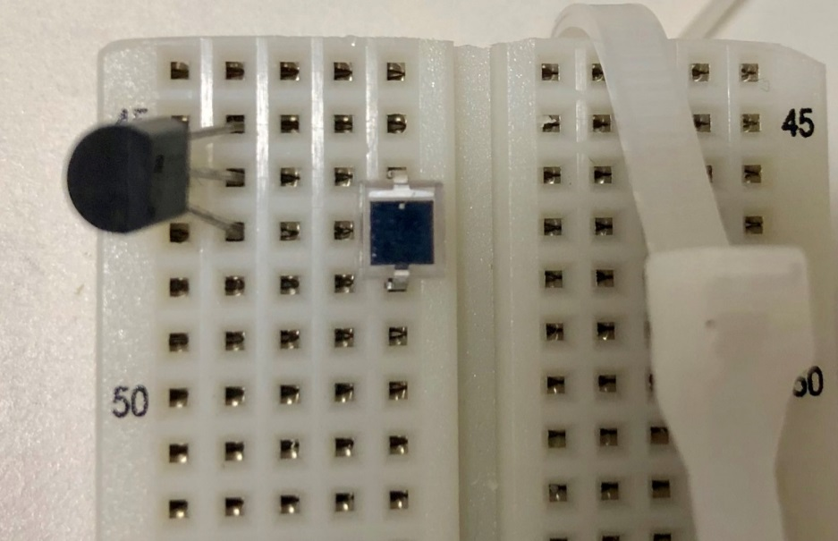

photodiode cathode

**Figure 9.6** Photodiode connection on breadboard

**Step 5:** Solder connecting wires to the motor (if your motor does not have wires on it already). The black wire from the motor should be connected to the cathode of the photodiode and the red wire to the transistor Collector as shown in Figure 9.7. (Note: If the wires from the motor are switched, the RollerBot will move in backwards - simply reverse the red and black wires).

photodiode cathode transistor collector

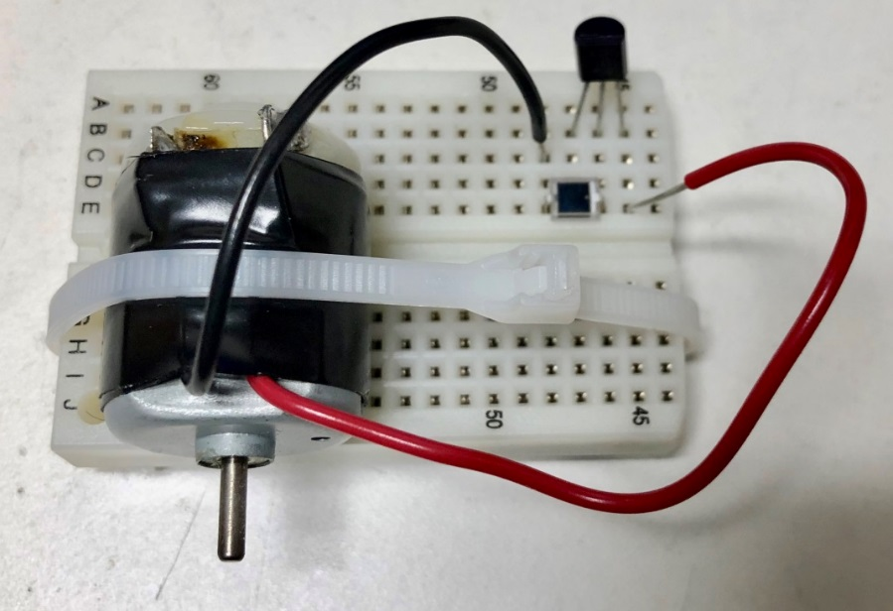

**Figure 9.7** Motor connections on breadboard

**Step 6:** Connect a 68 KΩ resistor between the base and emitter of the transistor. Increasing the value of this resistor will increase the RollerBot’s sensitivity to light. Conversely, reducing the value will decrease the sensitivity.

**Step 7:** Use zip- lock ties and/or electric tape to secure the breadboard to the paint roller. See Figure 9.8 for positioning. Connect a rubber band from the shaft of the DC motor to the yellow roller. This is how your RollerBot will move – adjust the positioning of your breadboard to ensure that you have slight tension in the rubber band.

**Step 8:** Using electrical tape, secure the 9V battery to the paint roller behind the breadboard. Connect the positive battery terminal to the photodiode cathode and the negative terminal to the transistor Emitter. Your finished product should look similar to the one shown in Figure 9.8.

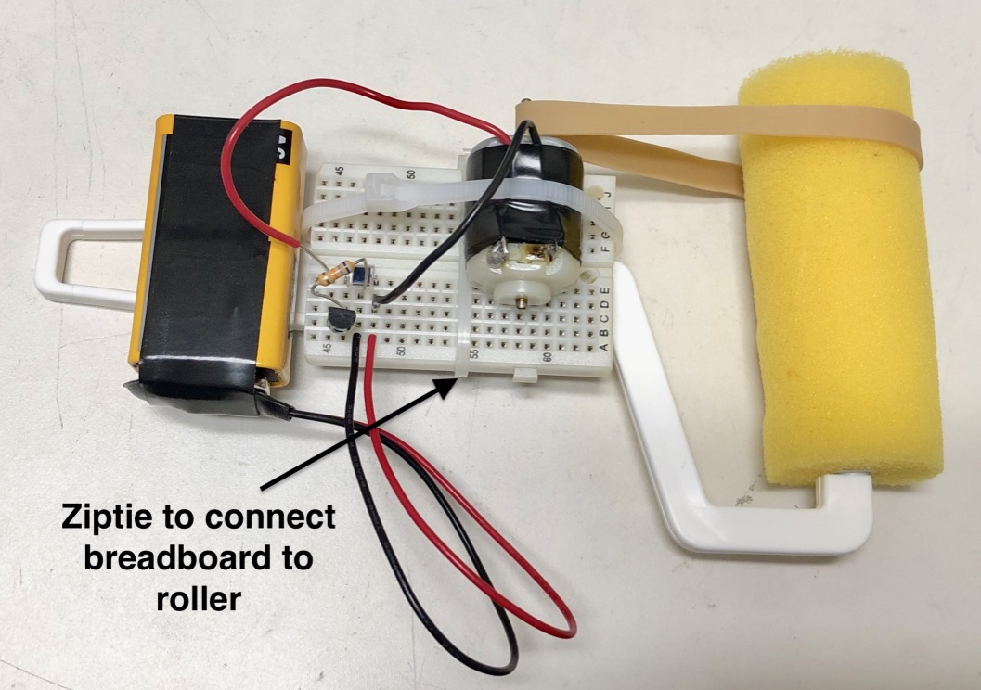

**Figure 9.8** RollerBot Assembly

**Step 9:** Attach a binder clip tail-hook on the roller handle to reduce friction. Test your RollerBot and check that it moves without falling apart. (You are Engineers - quality control is crucial!)

**Note:** If your Rollerbot is moving backwards, switch the motor leads.

**Note:** Use your cell phone flash light to shine light on the photodiode. if your Rollerbot moves without you shining a light on the photodiode, your circuit is not correct. The photodiode is like a switch in the circuit.

**Step 10:** If you are satisfied with your work, call the instructor or TA to test your product.

**Note:** If the light from your cell-phone does not work, use an incandescent source of light – like an old fashioned (not LED) flashlight.

You can take the RollerBot home as a souvenir. Hang it using the binder-clip.

If you do not want it, take it apart and put the components back.

That’s it—Good luck with the rest of your semester!!